***Final Project- Programming in internet environment***

**Presenter: Ilay zeidman, Id: 300634524**

Subject: To build a website to my wife that will organize all her recipes that scattered in many places.

Requirements: the site must contain a database that will store all the recipes.

Every recipe should have a main category for example cheese cake is in a cakes category.

In addition every recipe can have navigation properties for example cheese cake is dairy and sweet.

In the site you can find a recipe by its name or it's description

In the site you can add new recipes, delete and update and add or remove navigation properties.

The site must be very user friendly and easy for use .

The site and all its contents should be in **Hebrew**.

**Implementation**: Database: The database will contain fix tables:

**1:** Table for recipe.

**2:** Table for main category.

**3:** Table for navigation property.

**4:** Table for user.

**5:** Table for the many to many relationship between recipe and navigation property.

**6:** Table for the many to many relationship between user and recipe.

**Database Constraints**:

* The recipe and main category tables will have a one to many relationship, every recipe have exactly one main category and every main category can have many recipe associated to it.
* The recipe and navigation property will have a many to many relationship thus will be a table RecipeNavigation that contains the keys of both.
* The user and recipe will have a many to many relationship thus will be a table UsersRecipes that contains the keys of both. Here is a class diagram illustrates this constraints:

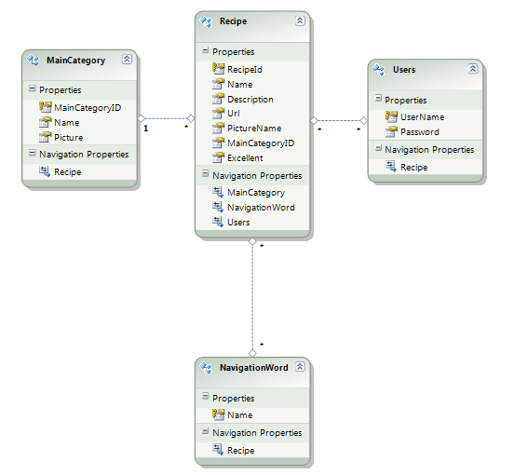

**Project**: I used ASP.NET MVC framework for the site, this framework implements the model view controller pattern.

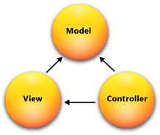

Model: Model objects are the parts of the application that implement the logic for the application's data domain. Often, model objects retrieve and store model state in a database.

Views: Views are the components that display the application's user interface (UI).

Controller: Controllers are the components that handle user interaction, work with the model, and ultimately select a view to render that displays UI. In an MVC application, the view only displays information; the controller handles and responds to user input and interaction.

The pattern helps me create application that separates the different aspects of the application.

It help me specifies where each kind of logic should be located in the application.

**User guide**: run the application and you will see the home page you can press of one of the main categories in order to see all the recipes